Linearity and Background Checks using an Improved set up

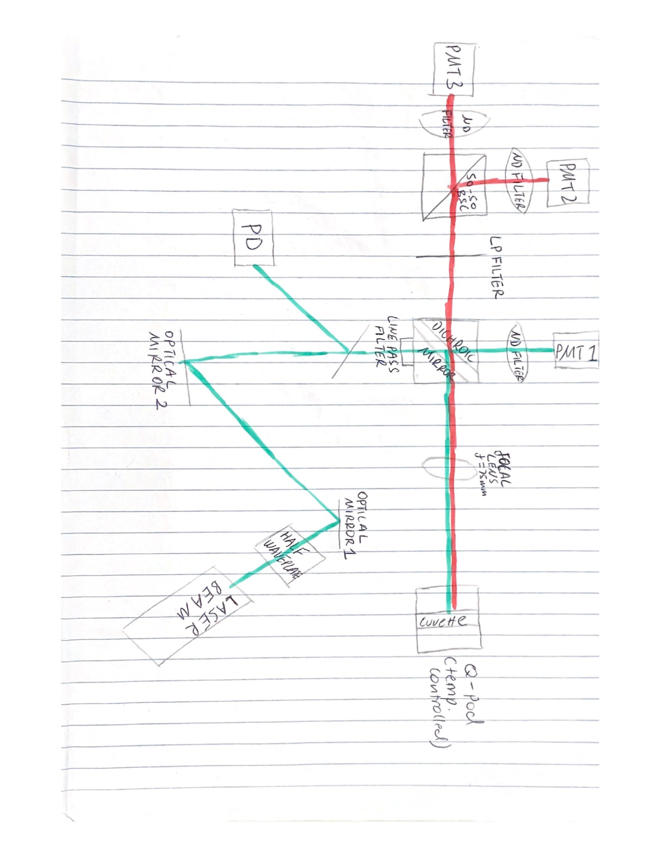Below is a schematic diagram which represents our previous set up:

When the data for linearity was first taken, there was a physically noticeable issue when rotating the half waveplate (for attenuation) on our system. The laser seemed to slowly misalign with the centre of the photodiode, this raised some concern so to be sure that it would not be a problem, a voltmeter was placed behind the glass film and the following data was obtained:

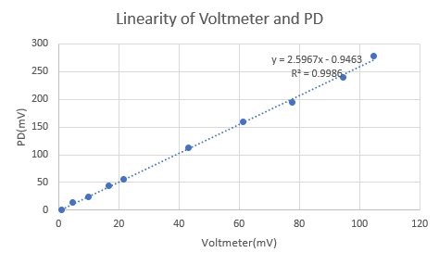

As shown, there is almost a perfect linear line generated by the points. The dotted line is a fitted curve to show the goodness of fit and it possess an R squared value of 0.9986. With this information, we can be confident that the slight misalignment when rotating the half waveplate should not be a problem.

From this exact same set up (without the voltmeter), the 2 Raman channels were now looked at in focus. Background and peak linearity information was collected and analysed, revealing an unusual observation for the Raman 640nm channel:

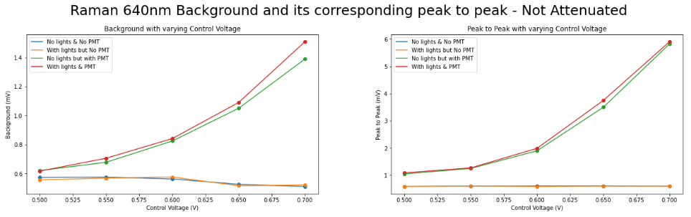When the lights are off (green curve – lower exponential curve), increasing the control voltage increases the background and peak to peak values. This should not be the case, especially when thinking physically about the background, how can the background increase with control voltage when there is no background – ambient light off, the attenuated graph looks the same. What was more troubling perhaps is this problem only happens for the Raman 640nm channel, below shows the results of the Raman 660nm channel:

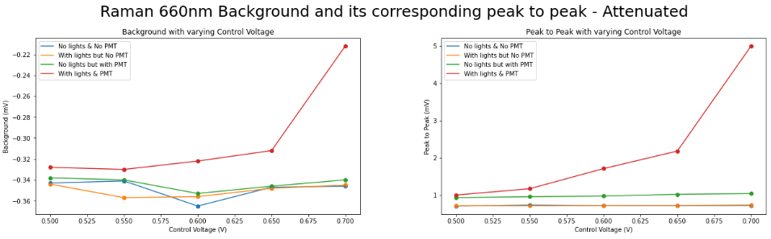Clearly, this is closer to what we expect. With no ambient should mean that the background and peak to peak doesn’t change when varying the control voltage.

Upon lengthy troubleshooting with Ondrej, it appears that even in the absence of ambient light, the Raman 640nm PMT is still photon counting. This can be shown in detail below:

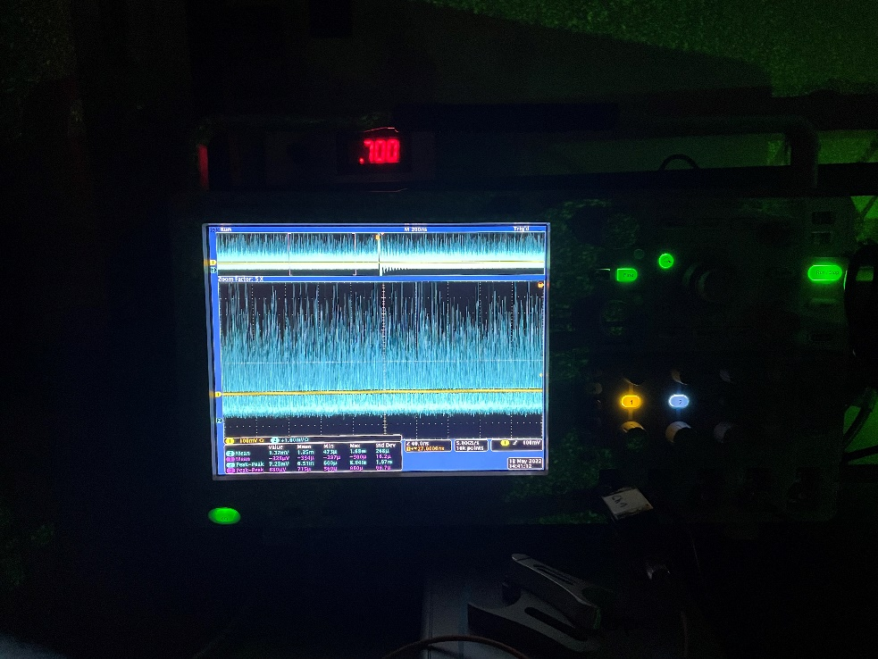

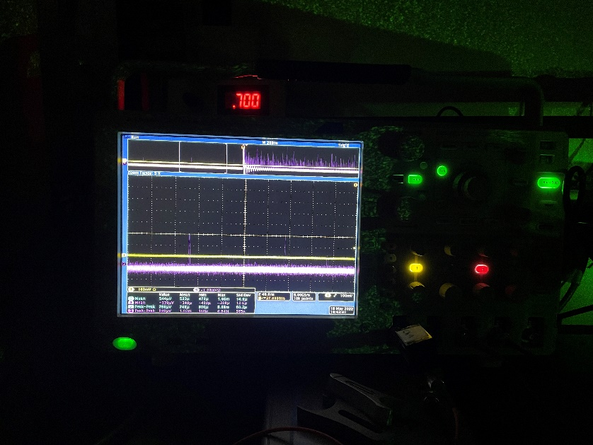In comparison to the Raman 660nm PMT which only sees photons rarely as shown below:

So, the background and peak to peak is actually not increasing (with increasing control voltage) due to the ambient light. It is increasing with control voltage due to the scattered green light leaking into the PMTs. We can even physically explain why the Raman 640nm channel is seeing much more photons, it is due to 2 reasons:

* PMT linked with the Raman 660nm channel has tape around its connection points so less photons can be detected, presumably because previously this was an identified problem (light can seep into the PMT).
* Raman 640nm PMT is physically much closer to the scattering of green light, while the Raman 660nm channel is behind

This can be clearly shown below:

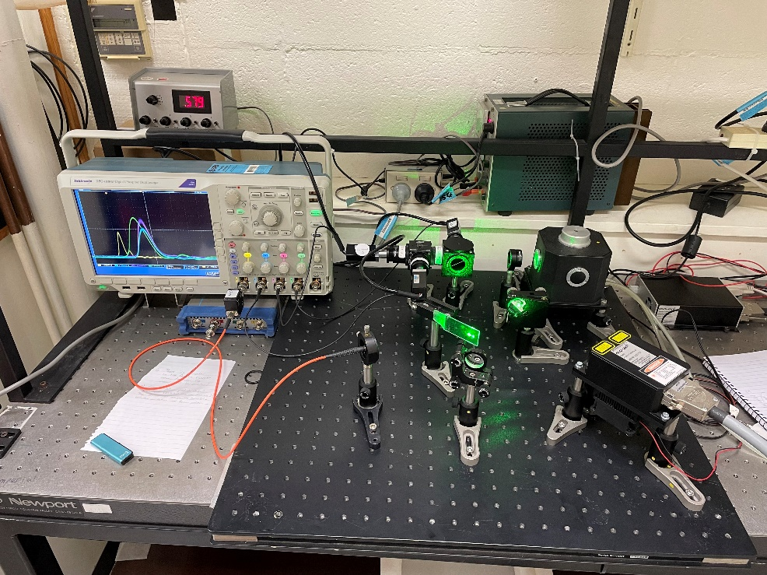

Raman 640nm PMT

Raman 660nm PMT

Radial scattering of green light in this direction

In the background, it is clear the direction of scattering will hit Raman 640nm PMT directly while Raman 660nm PMT is well hidden from the scattering.

To solve this issue, 2 large black dividers have been screwed in on either side dichroic mirror to block out most of the scattered green light, an aperture has been placed in the centre to block light being transmitted by the edges, black tape has been applied to vulnerable edges of the Raman 640nm PMT and finally, an extra green filter has been added to both PMTs.

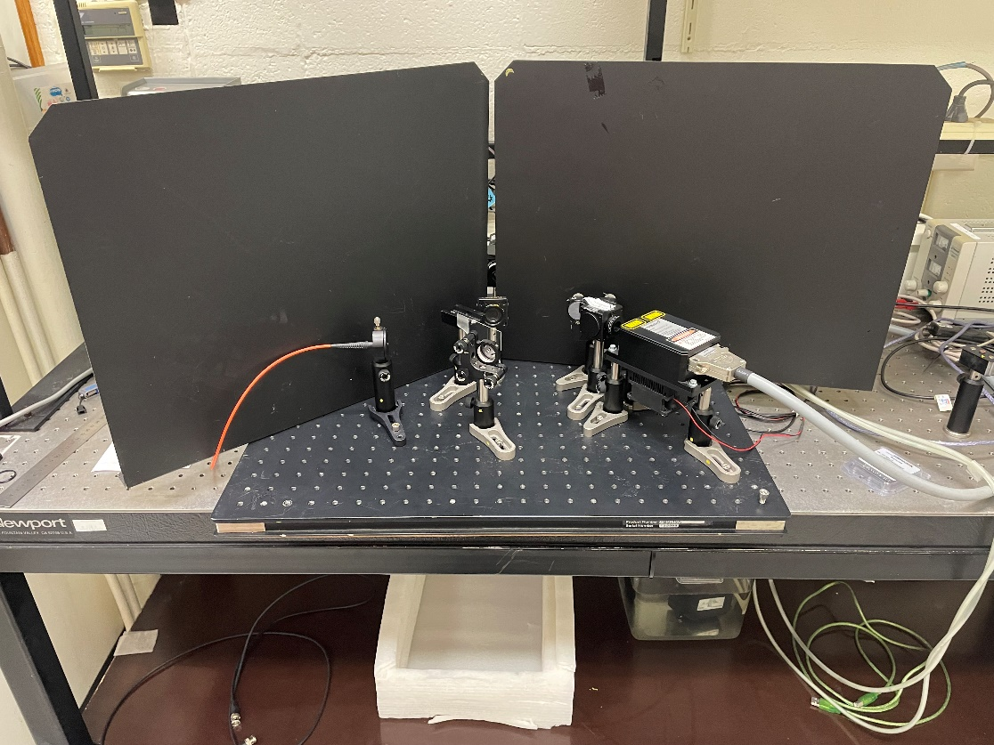The new set up is shown below:

Aperture

Black Dividers

The set up behind remains unchanged apart from the added long pass filters into both Raman PMTs and the tape around the Raman 640nm PMT. This set up was examined in the dark and now both PMTs have ceased to detect photons – a good sign.

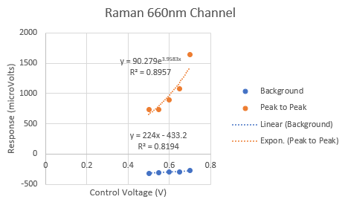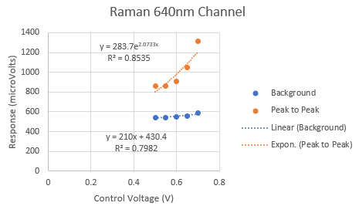With this new set up, the background/peak to peak and linearity experiments were both quickly repeated in Excel. The background/peak to peak experiment was conducted with the ambient light background and boasted the following results:

Given the uncertainties, it is possible to confidently say that the background remains constant while the peak-to-peak increases exponentially with increasing control voltage across both channels. This was repeated in the dark to make sure that both background and peak to peak stays constant, this is indeed true for our new set up.

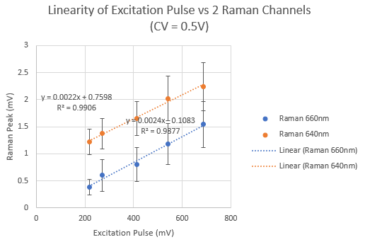The linearity experiment is conducted at 2 different control voltages, 0.5V and 0.7V. The changing excitation pulse is created by attenuating the laser using the half waveplate. The following is the result for control voltage of 0.5V:

It is clear to see that given the uncertainty, (0,0) is now a possible point on the line. The points are relatively linear and fitted lines have a really high R squared value.

A similar case is observed when increasing the control voltage to 0.7V:

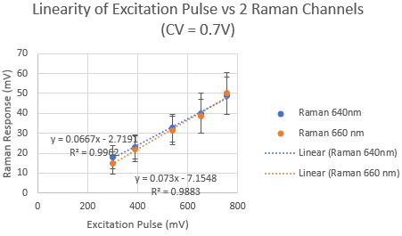

Again, with the uncertainties, it is possible that (0,0) is now a valid point, both Raman channels have good corresponding fitting lines with high R squared values. As the control voltage is increased, the points converge closer to each other and fall under similar uncertainties.